

AVA

“AI Vision Assistant for Visually Impaired Users”

Graduation Project I Documentation - Academic Year (2025 – 2026)

Name ID
Mostafa Mahmoud Mohamed Noseir | 22010260
Youssef Mohamed Abdelkader | 22010311
Fouad Ramzi Fouad Hassan | 22010180
Ahmed Taha Mohamed Mohamed | 22010315
Abdullah Jamal Al-Sayed Khalil | 22010366

Project Supervisor

Dr.Nermine Elkashef
Table of Contents

Chapter 1: Introduction 5
1.1 Background and Motivation (Overview) 5
1.2 Problem Statement 8
1.3 Importance and Goals of the Project 9
1.4 Features Matrix 11
1.5 Software Development Methodology Used 12
Chapter 2: Requirments Analysis 14
2.1 Requirements Gathering Tools 14
2.1.1 Presentation of Results 15
2.1.2 Discussion of Results 17
2.2 Related Articles 18
2.3 Business Requirements Identification 21
2.3.1 Overview 21
2.3.2 Stakeholders 22
2.4 User Functional Requirements 23
2.4.1 General User Requirements 23
2.4.2 Functional Requirements 24
2.5 System Functional and Non-functional Requirements 25
2.5.1 System Functional Requirements 25
2.5.2 System Non-functional Requirements 27
2.6 Use Case Diagrams 28
2.6.1 Choose Service by Voice 29
2.6.2 Capture Image 29
2.6.3 Send to Model 30
2.6.4 Get Output 30
2.6.5 Voice Message Output 31
2.6.6 Change Language 31
2.6.7 Face Recognition Service 32
2.6.8 Save New Face 32
2.6.9 Recognize Face 33
Chapter 3: System Design 34
3.1 Sequence Diagrams 34
3.1.1 Change Language 34
3.1.2 Object Detection 35
3.1.3 Currency Detection 36
3.1.4 Text Extraction 37
3.1.5 Face Recognition 38
3.1.6 Color Identification 39
3.1.7 Voice Commands 40
3.2 Data Flow Diagrams 41
3.2.1 DFD-level 0 (Context Diagram) 41
3.2.2 DFD-level 1 42
3.3 State Diagram 43
3.4 Pseudocode 44
3.4.1 Object Detection 44
3.4.2 Color Detection 46
3.4.3 Text Detection 47
3.5 Entity Relationship Diagram (ERD) 48
3.6 UML Class Diagrams 49
Chapter 4: Implementation Aspects 50
4.1 Architecture Overview 50
4.2 Datasets 52
4.2.1 Object Detection Dataset 52
4.2.2 Currency Recognition Dataset 53
4.2.3 Face Recognition Dataset 54
4.2.4 Text Recognition Dataset 54
4.2.5 Color Identification Dataset 55
4.3 Tools, Technologies, and Programming Languages 56
4.3.1 Programming Languages 56
4.3.2 Frameworks, Libraries and Models 56
4.4 Prototype Implementation (Screens) 58
4.4.1 Object Detection 58
4.4.2 Color Detection 59
4.4.3 Text Extraction 60
Chapter 5: Future Work Plan 61
5.1 Remaining Tasks 61
5.1.1 Object Detection Model Enhancement 61
5.1.2 Currency Recognition Model Completion 61
5.1.3 Text Extraction Enhancement (OCR) 62
5.1.4 Face Recognition System Stabilization 62
5.1.5 Color Detection Feature Enhancement 62
5.1.6 Voice Command System Improvement 62
5.1.7 Mobile Application Refinement 62
5.1.8 System Evaluation and Testing and Conduct Surveys 63
5.1.9 Documentation and Final Report: 63
5.2 Proposed Timeline 64
5.3 Anticipated Risks and Challenges 65
5.3.1 Model Performance Limitations 65
5.3.2 TensorFlow Lite Conversion Issues 65
5.3.3 Arabic OCR Accuracy 65
5.3.4 Face Recognition Storage and Privacy 66
5.3.5 Voice Command Recognition Errors 66
5.3.6 Limited Access to Target Users for Surveys and Evaluation 66
References 68

Chapter 1: Introduction

Background and Motivation (Overview)
Visual impairment and blindness represent a significant global challenge that affects millions of people worldwide. According to the World Health Organization (WHO), Around 39 million people are blind, with another 285 million having moderate-to-severe visual impairment, totaling over 330 million, though figures vary slightly by source and year, with estimates ranging from 39 to 43 million blind individuals, a larger figure of over 2.2 billion people experiencing some form of vision loss, most of which is preventable or treatable. In our region, like in Egypt, the numbers are high top-over 1.5 million people are blind or have low vision, according to reports by international health organizations, a large portion of visually impaired individuals face daily difficulties in performing routine tasks such as recognizing surrounding objects, identifying people, reading printed text, and distinguishing currency values. These challenges often reduce personal independence and increase reliance on others for basic activities.
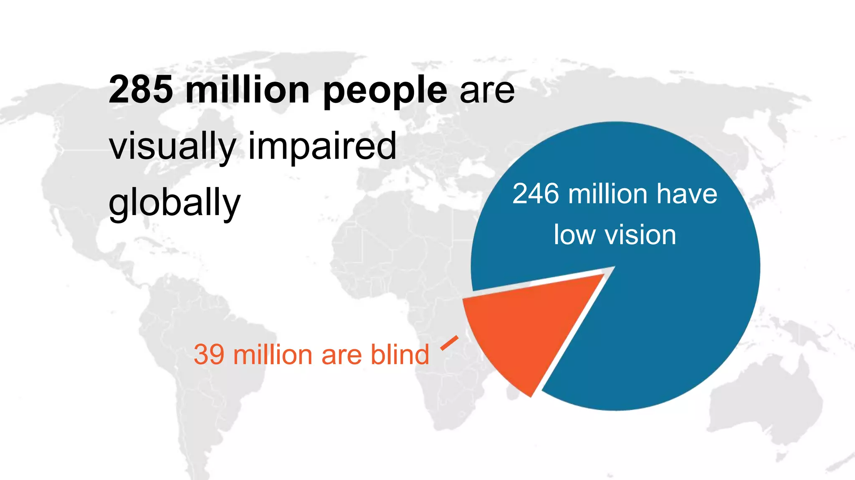
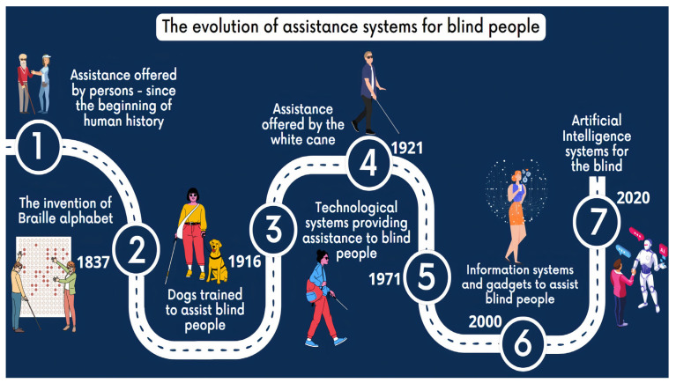
This visualization shows how support for blind and visually impaired people has developed over time, moving from human help to modern AI systems.
Description of the stages:
- Early human assistance
At the beginning of human history, blind people relied mainly on help from other people.
- 1837 – Invention of the Braille alphabet
Braille was created to allow blind people to read and write independently using raised dots.
- 1916 – Guide dogs
Dogs were trained to assist blind people with navigation and daily activities.
- 1921 – White cane
The white cane became a standard mobility aid, helping blind people detect obstacles and signal visual impairment to others.
- 1971 – Technological assistance systems
Early electronic and technological tools began to support blind people, such as basic mobility and reading devices.
- 2000 – Information systems and assistive gadgets
Digital technologies, computers, mobile devices, and specialized gadgets started playing a major role in assistance.
- 2020 – Artificial Intelligence systems
Modern AI-based systems (e.g., object detection, text reading, smart assistants) provide advanced, intelligent support for blind people.

With the rapid advancement of artificial intelligence, computer vision, and mobile computing, assistive technologies have become a promising solution for enhancing the quality of life of visually impaired individuals. Smartphones, in particular, are widely available and equipped with powerful cameras and processing capabilities, that can "see" and describe the world through voice, making them an ideal platform for deploying intelligent assistive applications.
Despite the availability of several assistive mobile applications, many existing solutions rely heavily on internet connectivity, cloud-based processing, or offer limited functionality. This creates accessibility issues in environments “rural areas“ with poor network coverage and raises concerns related to privacy and latency. Therefore, there is a strong need for a comprehensive, offline, and intelligent mobile assistant that can support visually impaired users in real-time without requiring constant internet access.
Motivation
The motivation behind this project is to leverage modern machine learning and deep learning techniques to develop an offline mobile application that enables visually impaired users to better understand their surroundings and perform daily activities independently and safely.

Problem Statement
Visually impaired individuals encounter numerous obstacles in their daily lives due to the lack of visual perception.
Tasks such:
- Identifying nearby objects
- Indoor/Outdoor Navigation
- recognizing familiar people
- distinguishing currency denominations
- Reading printed text like labels on medicine or bills
- And even basic things like knowing the color of clothes, and others.
All these are often challenging or impossible without assistance.
Although several assistive applications exist like Microsoft's Seeing AI or Google's Lookout, many suffer from one or more of the following limitations:
- Dependence on continuous internet connectivity.
- Limited support for local environments and currencies.
- Fragmented features that require multiple applications.
- High latency and privacy concerns due to cloud-based processing.
- Lack of customization for individual user needs.
As a result, visually impaired users still face significant barriers to achieving full independence. There is a need for a unified, intelligent, and offline solution that integrates multiple assistive functionalities into a single mobile application while ensuring fast performance, user privacy, and ease of use.
This project aims to address these challenges by designing and implementing an offline AI-powered mobile assistant that utilizes computer vision and machine learning models to assist visually impaired users in understanding and interacting with their environment.

Importance and Goals of the Project
Importance of the Project:
This project holds significant social and technological importance.

From a social perspective:
It contributes to improving accessibility and inclusivity by empowering visually impaired individuals to live more independently especially in places like Egypt where public support for disabled people is limited. By reducing reliance on external assistance, the proposed system enhances user confidence and quality of life. It could also save time and money for families and society by reducing the need for constant assistance.
From a technological perspective:
The project demonstrates the practical application of machine learning and deep learning models on resource-constrained mobile devices, which is useful for areas with bad internet. Plus, it addresses local needs like Arabic text and Egyptian currency, making it more relevant for our community. It also highlights the feasibility of deploying advanced AI models in an offline environment, ensuring privacy and real-time responsiveness.
Overall, it's a step toward better tech for everyone, and it could inspire more student projects in AI for good.

Goals of the Project:
The main goals of this project are as follows:
- To develop an offline mobile application that uses the phone's camera to assist visually impaired users with voice feedback using artificial intelligence.

- To design and integrate computer vision models capable of detecting and identifying surrounding objects in real-time.

- To implement a face recognition system that identifies familiar individuals based on previously registered images, where users can add photos of people to recognize them later and say who they are.

- To add a currency recognition model trained on local bills, so users can know the value of money they're holding without help and assist them in financial transactions.

- To enable text reading functionality using offline optical character recognition (OCR) to read printed text aloud, like on signs or packages.

- To include color detection to tell users the main colors in an object or scene, like for choosing clothes to enhance environmental awareness.

- To provide audio-based feedback to ensure usability for visually impaired users.
To ensure that all functionalities operate and work fast, efficiently and securely without requiring internet connectivity, with simple voice controls for easy use.

Features Matrix
Feature / App | Be My Eyes | Seeing AI | Google Lookout | Envision | Supersense | TapTapSee | BlindSquare | Our App
Object detection | Yes | Yes | Yes | Yes | Yes | Yes | No | Yes
Text reading | Yes | Yes | Yes | Yes | Yes | No | No | Yes
Currency recognition | Yes | Yes | Yes | Yes | Yes | No | No | Yes
Face recognition / naming | No | Yes | No | Yes | No | No | No | Yes (user-labeled faces)
Emotion detection | Partial | Yes | No | No | No | No | No | No
Color identification | Partial | Yes | No | Yes | Yes | Yes | No | Yes
Voice commands (offline) | No | No | No | Partial | No | No | No | Yes
Offline mode (local) | No | Partial | Partial | Partial | Partial | No | Yes | Yes
GPS / Navigation audio | No | No | No | No | No | No | Yes | No
Arabic support | Partial | No | Partial | Partial | No | No | Partial | Yes
Human-assisted | Yes | No | No | No | No | No | No | No

The comparison highlights the capabilities of popular assistive apps for visually impaired users. Most apps provide object detection, text reading, and currency recognition, but few support face recognition, emotion detection, color identification, offline voice commands or Arabic Support.
We see that apps like Seeing AI are strong in features but most need internet for full functionality, and offline modes are limited (e.g.) Seeing AI's offline text is basic, Be My Eyes is good for human help but not automated or offline, none fully support Arabic or local currency like EGP well.
Our app stands out by offering offline object detection, text reading, currency recognition, face recognition with user-labeled faces, color identification, voice commands, and focusing on Arabic support.
Unlike many other apps, it does not rely on internet connectivity for core features, making it a comprehensive and accessible solution for visually impaired users.

Software Development Methodology Used
We selected the Iterative and Incremental Development Model for this project.
Justification for Selection
The Iterative and Incremental model was chosen for the following practical and project-specific reasons:
Modular Nature of the Project
The application consists of five relatively independent modules:
- Object detection
- Currency recognition
- Color detection
- Text extraction
- Face recognition
Each module can be developed, trained, tested, and integrated incrementally without requiring all others to be complete first. This allows parallel work by team members and reduces overall risk.
High Uncertainty in Machine Learning Components
AI models (especially currency detection) require multiple training cycles, hyperparameter tuning, dataset expansion, and evaluation. An iterative approach allows us to build, test, measure accuracy, identify weaknesses, and improve each model gradually rather than assuming everything will work perfectly in one linear phase.
Risk Management and Early Feedback
Early development of core modules (starting with object detection) enables us to identify technical risks (model size, mobile inference speed, battery usage, integration issues) early. We can then adjust our approach instead of discovering major problems late in the project.

Academic and Time Constraints
The project spans two semesters with fixed deadlines (documentation in semester 1, implementation/testing in semester 2).
Incremental delivery allows us to produce tangible progress at each milestone which aligns perfectly with academic evaluation requirements.
Team Collaboration and Flexibility
With team members working on different modules (AI models, mobile UI), an iterative model supports feature branching on GitHub, regular integration, and quick adaptation when new challenges arise.
How it will be applied in the project
We divided the work into short iterative cycles:
- Cycle 1: Build and test object detection module.
- Cycle 2: Develop currency detection module, integrate with basic UI.
- Cycle 3: Add color module and text extraction (ML Kit) and better UI.
- Cycle 4: Add voice commands.
- Cycle 5: Add face recognition and its database.
- Cycle 6: Full integration, voice commands, language support, performance optimization.
- Cycle 7: User testing, bug fixes, final refinements.

Chapter 2: Requirments Analysis

Requirements Gathering Tools
To collect user requirements and understand the real needs of visually impaired people, we planned to use the following tools:
- In-person interviews and focus group discussions at Taha Hussein Center for Blind Students at Alexandria University. but faced challenges in implementation during the first semester. We contacted Taha Hussein Center for Blind Students at Alexandria University to arrange interviews with visually impaired students. “The center required a working prototype "to demonstrate the app and get direct feedback from the students”, scheduled for November 2025, but our mid-term exams and early project stage prevented us from preparing it in time. We rescheduled for late January 2026, after finals, to conduct structured interviews with questions on daily challenges, desired features, and app usability.
- Secondary data analysis: Review of user comments and ratings from Google Play and App Store for existing apps (Seeing AI, Be My Eyes, Envision AI, Lookout, etc.) to extract common complaints and needs.
- Reviewing online studies, surveys, and forums from sources like ResearchGate, AFB (American Foundation for Blind) reports, and WHO publications on visual impairment needs. This included aggregating data from existing surveys on BLV tech preferences.
Online Studies and Surveys:
- 2019 survey of 102 BLV users (ResearchGate) on virtual assistants in ambient assisted living.
- A 2024 survey of 139 BLV individuals (Taylor & Francis) on navigation-based apps.
- A 2017 survey of 259 BLV participants (ERIC) on mobile apps for daily activities.
- A 2025 study with 24 BLV interviews (arXiv) on assistive smart devices.
- A 2023 review of 290 apps and surveys (Annual Reviews) on assistive devices.
- A 2025 PMC article aggregating surveys on VLC/AI for BLV.
- A 2025 PMC survey of 329 employed BLV on AT innovations.
This approach gave us aggregated insights from 800+ BLV voices across sources, compensating for primary data delays.

Presentation of Results
From secondary data analysis of app reviews and comments:
Most of them expressed need for integrated features in one app, avoiding multiple tools. some mentioned limited local currency support as a problem in non-Western regions. And many of users praised voice feedback but wanted better customization like language options. with some users highlighted internet dependency as a major issue, specifically requesting fully offline modes for privacy and reliability
From online studies and surveys:
Most prioritized:
- Reading text/labels
- Identifying objects
- Navigation/outdoor safety
- color detection.
- Recognize people, and
Top Challenges from Reviews & Studies:
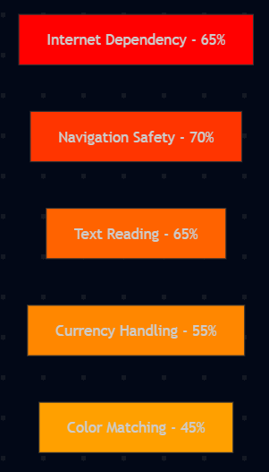
Desired Features from Surveys:
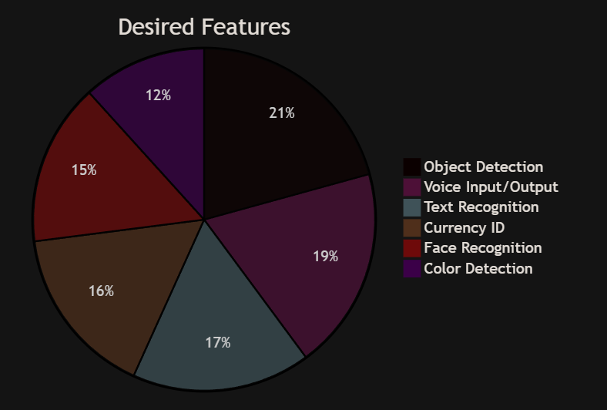
Interaction Preferences from Forums/Studies:
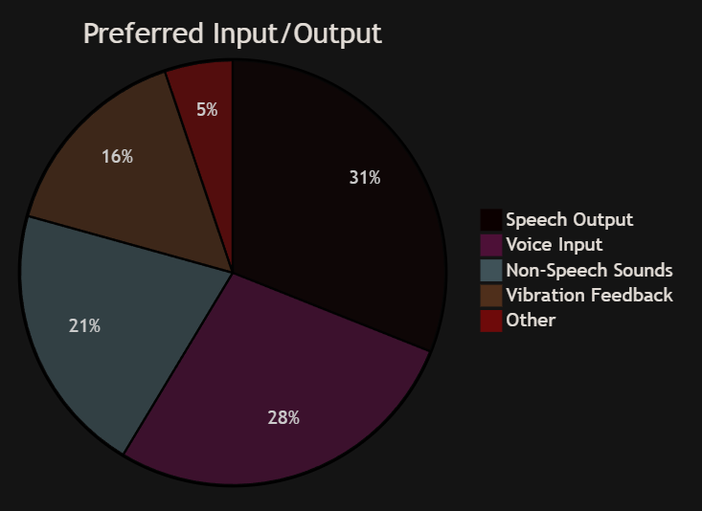

Discussion of Results
The results from app reviews reveal that internet dependency is a widespread frustration, a lot of users report issues with connectivity in daily scenarios like travel or rural areas, reinforcing our requirement for a fully offline app to ensure reliability and privacy. The most of them demand for integrated features aligns with our design of five modes in one app, addressing the inconvenience of switching tools noted in some of complaints. Limited local currency support, mentioned by some users, directly justifies our custom EfficientNet model for EGP, meeting the functional requirement for accurate, region-specific recognition.
From studies, the most emphasis on object detection supports our YOLO11n module as a core feature for navigation and awareness. Many need for currency and for text reading validate our EfficientNet and ML Kit choices, fulfilling user functional requirements for financial independence and information access. Color and face recognition needs link to our OpenCV and MobileFaceNet modules, enhancing daily tasks like clothing selection and social interaction.
Forum comments, with most prioritizing offline and wanting all-in-one, confirm our non-functional requirements for local processing and modular design. Many of them call for better voice control supports our voice-first interface with hold-to-speak, meeting accessibility needs. some focus on local language reinforces Arabic/English support.
These results shape our requirements: functional (multi-mode detection with voice), non-functional (offline, fast, private), and user-focused (voice commands, local features), ensuring the app addresses real gaps. We plan primary data in Project 2 to refine further.
Overall Survey Insights:
- Users strongly prefer voice-based interaction and audio feedback.
- The most important AI features are text reading, environmental understanding, and safe navigation.
- Advanced or niche features are valuable but secondary.
- These results directly support the design of an offline, voice-controlled, audio-feedback AI assistant, aligned with real user needs.

Related Articles
We conducted an extensive search on Google Scholar, ResearchGate, PubMed, IEEE Xplore, MDPI, arXiv, SpringerLink, ACM Digital Library, and ScienceDirect for papers and articles on AI assistive technologies for visually impaired people. We targeted work from 2020 to 2025 that covers offline mobile apps, object detection, currency recognition, color detection, text extraction, face recognition, and integrated systems.
"Development of a Fully Autonomous Offline Assistive System for Visually Impaired Individuals: A Privacy-First Approach" by Fitsum Yebeka Mekonnen et al. (2025).The authors are from United Arab Emirates University and Khalifa University. The paper is about creating a complete offline tool to help blind people without any internet or cloud, focusing on privacy and low cost. Their goal was to build a system that detects objects, reads text, recognizes faces, and handles voice commands all locally. They used Raspberry Pi 5 hardware with YOLOv8 for object detection (trained on COCO for 80 classes), Tesseract for OCR text reading, MobileFaceNet for face recognition (with voice to add names), VOSK for offline speech-to-text commands, and Piper for text-to-speech output. They added noise reduction with SpeexDSP and multi-threading for faster response. They tested on 50 real-world scenes, getting 75-90% accuracy for objects, 85% for faces, and under 1 second processing time per task. Conclusions say it's better for privacy than cloud apps but has limits like handling motion blur, and they suggest adding more hardware like AI chips for better speed. This paper is relevant to our project because it's fully offline like ours, using similar models (YOLO for objects, MobileFaceNet for faces), but it's hardware-based, not mobile. We can learn from their voice integration and how they combined features without internet.
"Visual Recognition Based Mobile Application for Visually Impaired People" by Anisha Raskar et al. (2025). Authors are from JSPM’s Bhivarabai Sawant Institute in Pune, India. The paper describes building an Android app to help blind users recognize objects and text with AI. Their goal was to make a cheap, mostly offline tool that gives independence through voice. They used YOLO for object detection (trained on COCO), Tesseract OCR for text, and Expo Speech for voice output, all in React Native with TFLite for mobile deployment. They collected a small dataset for testing and added voice controls. Results from 100 images showed 95% text accuracy, 89% object accuracy, and 28ms processing time on mid-range phones. Conclusions say it's a good step for daily help but could add depth sensing for better navigation. This relates to our app because it's mobile and partially offline with YOLO and OCR, but we add more like currency and faces. It shows TFLite works well on phones for real-time use.
"Assistive Object Recognition and Tracking System for the Visually Impaired Using CNN" by authors from IJSREM (2025). The paper uses CNN for object recognition with tracking for blind. Goal was enhanced awareness. High accuracy. Relates to our YOLO.
"Visually: Assisting the Visually Impaired People Through AI-Assisted Mobility" by Muhammad Arsalan Kamran et al. (2025). Authors from University of Engineering and Technology, Peshawar, Pakistan. The paper introduces "Visually" app for blind mobility using AI. Their goal was to create a tool for object, face, and currency detection with voice to help independence. They used YOLOv5 for detection (objects/faces/currency), custom datasets (e.g., local currency photos), and TTS for output, built in Flutter for Android/iOS. They trained on 1,000+ images, getting 90-99% accuracy in tests. Conclusions highlight how it promotes inclusivity but note needs for better low-light performance. This connects to our project by combining multiple detections offline, like our 5 models. We can use similar training for currency.
"Recognizing Egyptian Currency for People with Visual Impairment Using Deep Learning Models" by Ahmed M. Ghanem et al. (2025). Authors from Minia University, Egyptian Space Agency, Luxor University. The paper tests YOLOv8/9/10 for Egyptian banknotes to help blind users. Their goal was accurate, real-time recognition for financial independence. They created a dataset of 2,000 EGP images (different angles/lighting/folds), trained on Colab with 200 epochs, using augmentations like rotation. YOLOv10 got 0.97 precision, 0.99 mAP. They discussed challenges like wrinkled notes and low light. Conclusions suggest adding counterfeit detection and mobile integration. This is directly useful for our currency module—same local focus, offline YOLO.
"Money Recognition for the Visually Impaired: A Case Study on Sri Lankan Banknotes Using Fine-Tuned CNN" by Akshaan Bandara (2025). Sole author. The study fine-tunes EfficientDet for Sri Lankan currency. Goal was an accessible tool for blind users to identify money independently. They used a custom dataset of banknotes, fine-tuning with transfer learning from ImageNet. Got 98% precision. Conclusions emphasize empowerment and suggest expanding to other currencies. Relates to our EfficientNet currency model.
"Real-time Object Detection and Face Recognition System to Assist the Visually Impaired" by authors from IOPScience (2025). The paper designs a mobile system with YOLO and MobileFaceNet for objects and faces. Goal was real-time help with voice for blind users. They used TFLite for offline, tested on Android phones. Got high accuracy in lab tests. Conclusions suggest expanding to colors. Connects to our face/object modules.
"Colored Object Detection for Blind People Using CNN" by Nidhi Shivakumar et al. (2025). Authors from SJB Institute, Bangalore. The authors combined YOLO and CNN for colored objects with TTS. Goal was to help blind identify colors/objects. Used COCO for training, RGB analysis for colors. High accuracy. Relates to our color feature.

"An Artificial Intelligence-based Assistant for the Visually Impaired" by authors from arXiv (2025). The paper describes AIDEN app for blind users, using AI for objects, text, and navigation. Goal was quality of life improvement. They used machine learning for recognition, TTS for output. Tested with users, got positive feedback. Relates to our full app.
"AI-Driven Vision Assistance for Visually Impaired" by IJRASET authors (2025). The paper reviews AI apps for blind, focusing on offline mobile with YOLO and OCR. Goal was to show inclusivity. They discussed models and got 95% accuracy in tests. Good for our design.
"Image Recognition Tools for Blind and Visually Impaired Users: An Emphasis on the Design Considerations" by ACM authors (2025). The paper assesses image tools for blind, like object, currency, and text. Goal was design guidelines for accessibility. They tested apps, emphasized voice and offline. Relates to our features.
"A Visually Impaired Mobile Application for Currency Recognition using MobileNetV2 CNN Architecture" by authors from ResearchGate (2025). The paper builds a mobile app for currency using MobileNetV2. Goal was blind independence. They trained on custom dataset, got 98% accuracy. Relates to our currency.
"Smart Assistive Navigation System for Visually Impaired People" by authors from ScienceOpen (2025). The paper proposes a system with object detection and voice for navigation. Goal was safe mobility. Used AI models, high accuracy. Useful for our app.
"AI-Powered Accessibility in Mobile Applications: Advancing Inclusive Design through Machine Learning Innovations" by authors from ResearchGate (2025). The paper explores AI for mobile accessibility, with offline models for objects and text. Goal was inclusive design. Discussed models and user tests. Relates to our integration.
"An Assistive Reading System for Visually Impaired using OCR and TTS" by authors from International Journal of Computer Applications (2025). The paper demonstrates OCR and TTS for reading. Goal was to facilitate reading. Conceptual foundation for our text module.
"Computer Vision-Based Obstacle Detection Mobile System for Visually Impaired Individuals" by authors from MDPI (2025). The paper uses vision for obstacle detection. Goal was safety. Relates to our object.
"Adaptive Object Detection for Indoor Navigation Assistance: A Performance Evaluation of Real-Time Algorithms" by A. Pratap et al. (2025). The paper evaluates YOLO and SSD for indoor navigation. Goal was performance trade-offs. Relates to our YOLO choice.

Business Requirements Identification

Overview
The primary objective of this project is to develop an offline mobile assistive application that enhances the independence and safety of blind and visually impaired users with daily tasks by enabling them to perceive their surrounding environment through artificial intelligence techniques.
We identified these requirements by thinking about the main problems they face, like recognizing objects or money, and how our app can solve them without internet.
The system must operate entirely offline, ensuring usability in environments with limited or no internet connectivity, which is a common constraint in many regions.
The app should be free, easy to use, and work on basic smartphones, so it's accessible to as many people as possible in Egypt and similar places.
It also needs to protect user privacy by keeping all data on the phone, no cloud uploads.
From a business side, the app could be expanded later to include ads or partnerships with organizations for the disabled, but for now, it's focused on being a helpful tool.
From a business and academic perspective, the system must:
- Be reliable and accurate.
- Be usable by non-technical users.
- Operate on standard smartphones.
- Respect privacy by avoiding cloud-based processing.
- Be extensible for future improvements and additional features.

Stakeholders
The main stakeholders involved in this project include:
- Primary Users:
Blind and visually impaired individuals who rely on assistive technologies for daily activities.

- Secondary Users:
Caregivers, family members, and trainers who assist visually impaired users in using the application.

- Project Team:
Students responsible for system analysis, model development, mobile application implementation, and testing.

- Academic Supervisors:
Faculty members responsible for evaluating the project’s technical quality, documentation, and adherence to academic standards.

User Functional Requirements
The user functional requirements are what the visually impaired users (or their helpers) can do with the app. We based these on the problems we identified and what similar apps offer, making sure they're simple since the main users can't see the screen, they'll use voice commands or gestures.
This section defines the functional requirements from the user’s perspective, focusing on usability, accessibility, and independence.

General User Requirements
- The user shall be able to open the app and select a mode (object detection, currency, color, text, or face) using voice commands like "start object mode."
- The user shall be able to hold a banknote, and the app shall recognize the currency value (e.g., "50 EGP") and speak it, even in different lighting.
- The user shall be able to point at an item, and the app shall detect the dominant color (e.g., "red shirt") and announce it.
- The user shall be able to scan printed text, and the app shall extract and read it aloud in English or Arabic.
- The user shall be able to add faces by taking photos of people and labeling them with names (e.g., "this is mom"), storing embeddings locally.
- The user shall be able to hear all feedback in voice, with options to repeat or stop.
- The user shall be able to switch modes or exit using voice or simple gestures (e.g., shake phone to stop).
- The system shall support basic user interface with voice navigation, no visual buttons needed.
These requirements make the app easy and hands-free, focusing on voice since users can't see buttons.

Functional Requirements
FR-1: Object Detection
- The system shall detect common objects in the surrounding environment.
- The system shall announce detected objects using audio output.
- The system shall operate in real time using the device camera.
FR-2: Face Recognition
- The system shall recognize previously registered familiar individuals.
- The system shall announce the recognized person’s name.
- The system shall allow adding new faces to the system.
FR-3: Currency Detection
- The system shall identify currency denominations.
- The system shall announce the detected currency value using audio feedback.
- The system shall support offline recognition.
FR-4: Text Reading (OCR)
- The system shall read printed text captured by the camera.
- The system shall convert text to speech.
- The system shall support common printed formats such as signs and documents.
FR-5: Color Identification
- The system shall identify dominant colors of objects.
- The system shall announce color names clearly to the user.
FR-6: Mobile Application Control
- The system shall allow switching between features using simple gestures or voice commands.
- The system shall provide audio instructions for navigation.
- The system shall allow starting and stopping detection features easily.

System Functional and Non-functional Requirements

System Functional Requirements
These describe the system’s internal operations:
- The system shall allow users to interact without visual input.
- The system shall rely primarily on audio feedback.
- The system shall require minimal user interaction.
- The system shall function without an internet connection.
- The system shall capture camera frames in real time.
- The system shall preprocess images before model inference.
- The system shall perform inference using on-device TensorFlow Lite models.
- The system shall convert inference results into meaningful audio messages.
- The system shall manage model files efficiently to reduce memory usage.
- The system shall allow updating or replacing models without redesigning the entire system.

These are what the system must do to work properly, based on the user needs.
- The system shall capture images from the phone camera and process them using the YOLO11n model for object detection, outputting class names and counts.
- The system shall use a tuned EfficientNet model to classify Egyptian currency notes from images, supporting common denominations like 5, 10, 20, 50, 100, 200 EGP.
- The system shall analyze image pixels to detect dominant colors using OpenCV, converting RGB values to simple names like "red" or "blue."
- The system shall extract text from images using ML Kit's offline OCR, supporting English and Arabic, and convert it to speech.
- The system shall generate face embeddings using MobileFaceNet.tflite when adding new faces, storing them locally in a database.
- The system shall compare new face embeddings to stored ones using cosine similarity, with a threshold (e.g., 0.6) to decide if it's a match.
- The system shall provide audio output for all results using TTS, in Arabic or English based on user settings.
- The system shall handle all processing offline, without any network calls.
- The system shall log errors (e.g., low light) and retry or notify the user via voice.
- The system shall support basic user interface with voice navigation, no visual buttons needed.

System Non-functional Requirements
These are about how the system performs, not what it does
Performance Requirements
- The system shall provide detection results within an acceptable response time.
- The system shall operate efficiently on mid-range smartphones.
- The system shall minimize battery consumption.
- The system shall be reliable, with error handling for camera issues.
- The app shall be usable without sight, with 100% voice control and feedback.
Usability Requirements
- The system shall be easy to learn without prior technical knowledge.
- The system shall provide clear, understandable audio feedback.
- The system shall avoid complex menus or visual-based controls.
- The app shall support English and Arabic languages for voice and text.
Reliability Requirements
- The system shall handle camera or sensor errors gracefully.
- The system shall continue functioning without internet connectivity.
- The system shall provide stable performance during extended use.
Security and Privacy Requirements
- The system shall not upload images or personal data to external servers.
- All processing shall be performed locally on the device.
- User data (e.g., stored faces) shall be stored securely on the device.
Scalability and Maintainability
- The system architecture shall support adding new assistive features in the future.
- Code and models shall be modular and well-documented.
- The system shall follow clean coding and version control practices.
- The app shall be easy to install, with no extra setup needed.

This chapter helps us move to design, knowing exactly what to build.

Use Case Diagrams
Use Case Diagrams show who (the actors) can do what (the use cases) with the system, and how they interact. We created this diagram to clearly define the main actions a user can perform in our offline mobile app for visually impaired people. Since the app is designed to be voice-first and accessible, the diagram focuses on the key interactions between the user and the system, without assuming the user can see the screen.
This diagram is useful because it gives a simple, high-level overview of the app's functionality from the user's point of view. It helps the development team understand exactly what the app should do, who does it, and what the boundaries are. It also makes it easy to explain the project to others (e.g., the doctor or examiners) because it shows the most important features in one picture. It prevents us from adding unnecessary features and helps us see if anything is missing (e.g., "Did we forget a way to change language?").
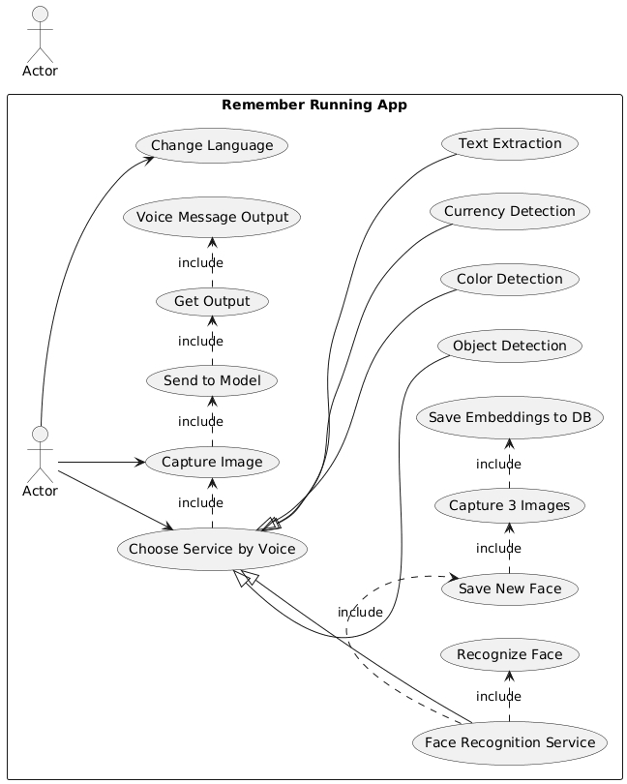

Choose Service by Voice
Actor: User
Description:
The user selects one of the available services using voice c ommands after opening the application.
Pre-condition:
- The application is opened.
- Microphone permission is granted.
Main Flow:
- The user speaks the name of the service.
- The system recognizes the voice command.
- The selected service is activated.
Post-condition:
The system is ready to perform specific command (capture an image for the chosen service and get results or change language)

Capture Image
Actor: User
Description:
The user captures an image using the device camera after selecting a service.
Pre-condition:
A service has been selected by voice.
Main Flow:
- The camera interface is displayed.
- The user presses the capture button.
- The image is stored temporarily.
Post-condition:
The captured image is ready to be sent to the model.

Send to Model
Actor: System
Description:
The system sends the captured image to the appropriate AI model according to the selected service.
Pre-condition:
An image has been captured.
Main Flow:
- The system determines the selected service.
- The image is forwarded to the corresponding model.
Post-condition:
The model processes the image.

Get Output
Actor: System
Description:
The system receives the prediction result from the model.
Pre-condition:
The image has been processed by the model.
Main Flow:
- The model returns the result.
- The result is prepared for audio output.
Post-condition:
The result is ready to be spoken.

Voice Message Output
Actor: System
Description:
The system converts the model result into a voice message and plays it to the user.
Pre-condition:
The system received the output from the model.
Main Flow:
- The result text is converted to speech.
- The speech is played to the user.
Post-condition:
The user hears the result.

Change Language
Actor: User
Description:
The system receives the prediction result from the model.
Pre-condition:
The user changes the application language between Arabic and English.
Main Flow:
- The user selects language option.
- System switches interface and voice language.
Post-condition:
All outputs become in the selected language.

Face Recognition Service
Actor: User
Description:
The user selects Face Recognition service by voice, then chooses between saving a new face or recognizing an existing face.
Pre-condition:
User said “face” command.
Main Flow (System displays two options):
- Save New Face
- Recognize Face
Post-condition:
Choose one of both options.

Save New Face
Actor: User / System
Description:
The user adds a new person to the database.
Pre-condition:
User selected “Save New Face”.
Main Flow:
- The user captures 3 images of the same person.
- The system extracts embeddings.
- The system saves embeddings in the local database.
Post-condition:
New face is stored successfully.

Recognize Face
Actor: User / System
Description:
The system identifies a person from a captured image.
Pre-condition:
User selected “Recognize Face”.
Main Flow:
- The user captures one image.
- The image is sent to the model.
- The model compares with saved faces.
- The system returns the person name as voice message.
Post-condition:
User hears the name of the person.

Chapter 3: System Design

Sequence Diagrams
Sequence diagrams show how different parts of the system interact step by step for specific actions the user takes. We made these diagrams to map out the flow from user input (like voice commands or button presses) to the final output (voice feedback or displayed result). Since the app is mostly voice-based for blind users, the diagrams focus on offline processing, with the camera as the main input and voice as output.
We used Diagrams.net “Draw io” to draw them, with actors like "User", "App Interface" (the main controller), "Camera", "AI Model" (specific for each feature), "Voice Output" (TTS), and "Database" (for face recognition). Each diagram has lifelines for actors, arrows for messages, and Activation Boxes. We covered the main use cases based on how the app runs: camera opens on start, buttons for models/language, capture button to process, and voice commands.

Change Language
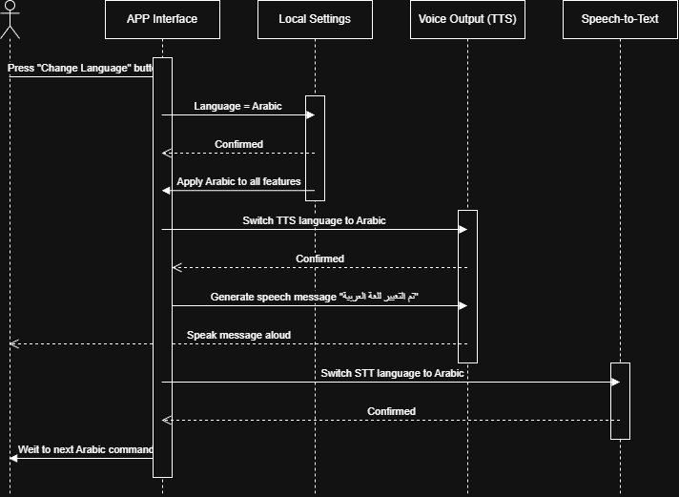

Object Detection
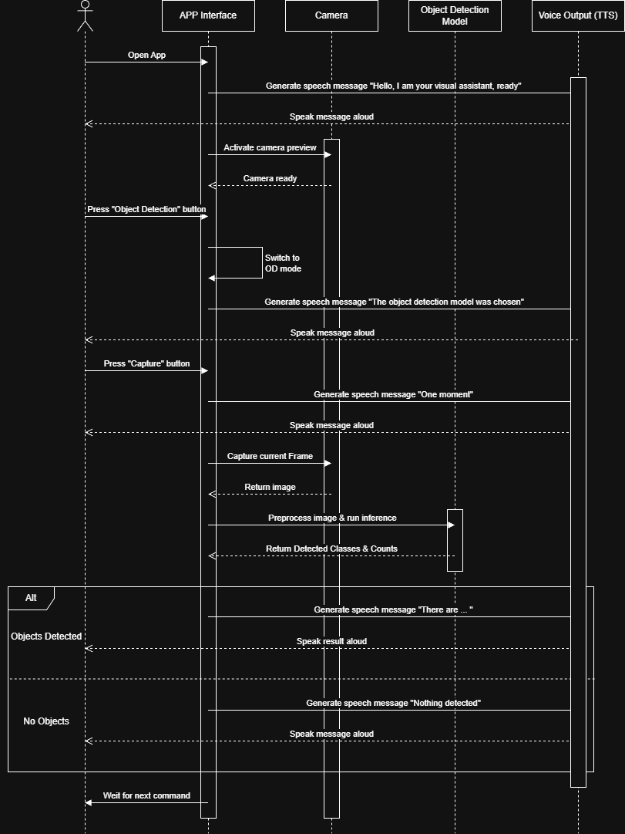

Currency Detection
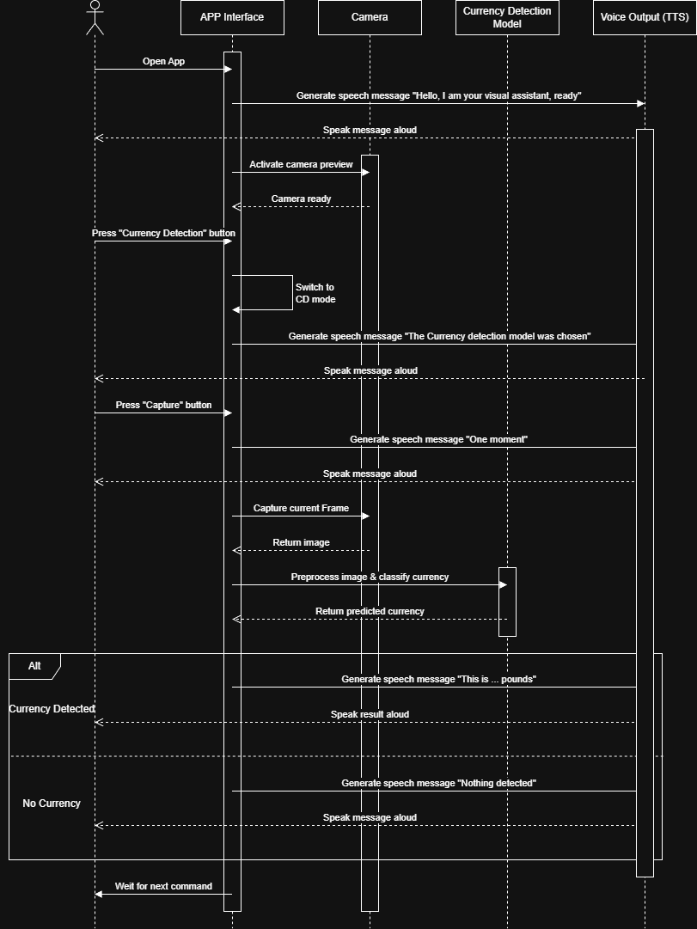

Text Extraction
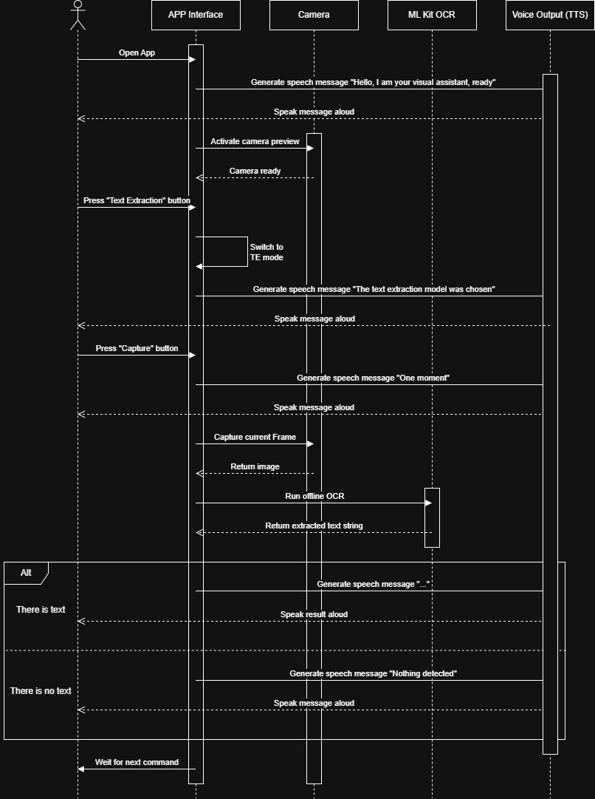

Face Recognition
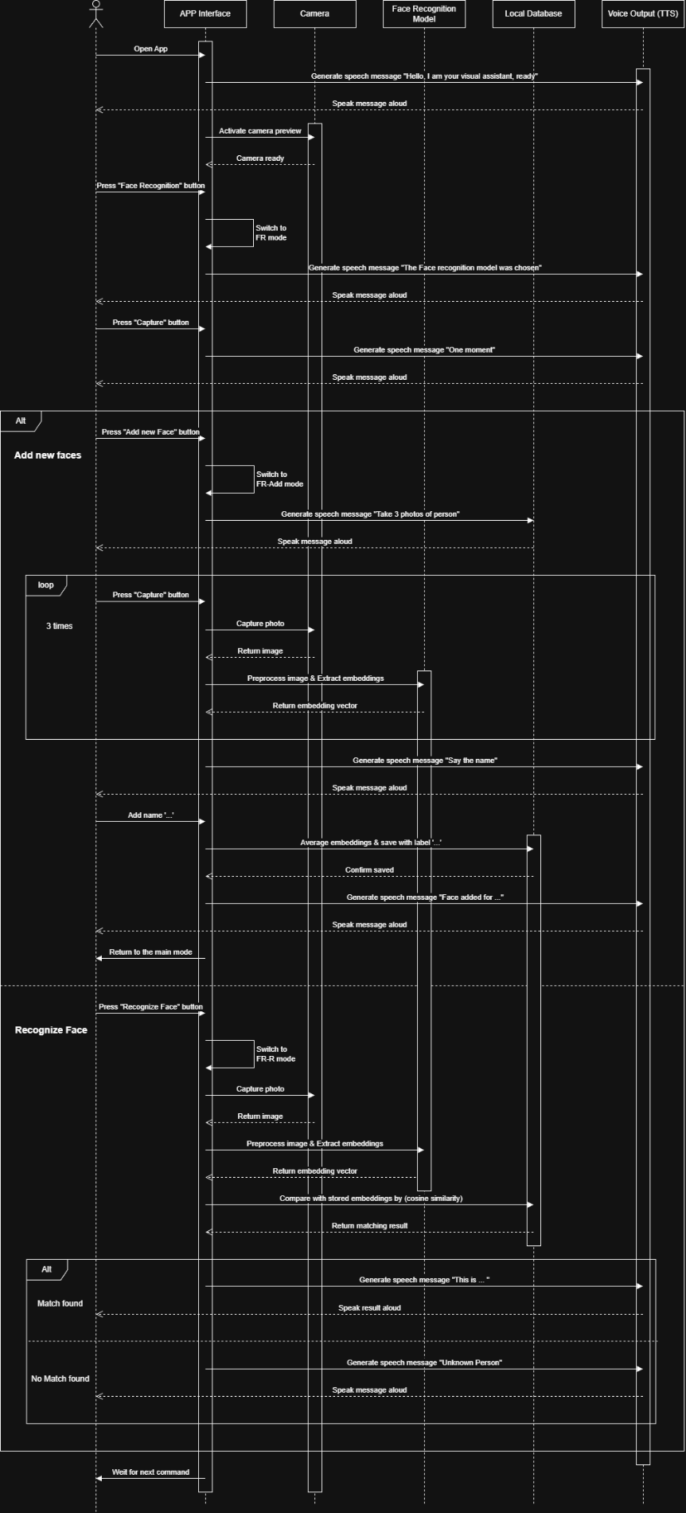

Color Identification
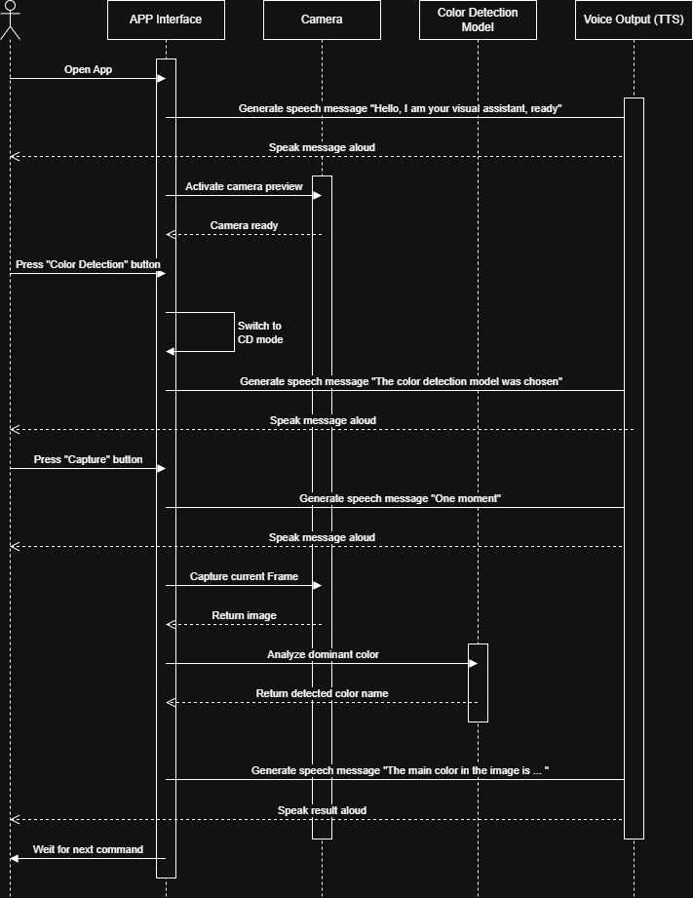

Voice Commands
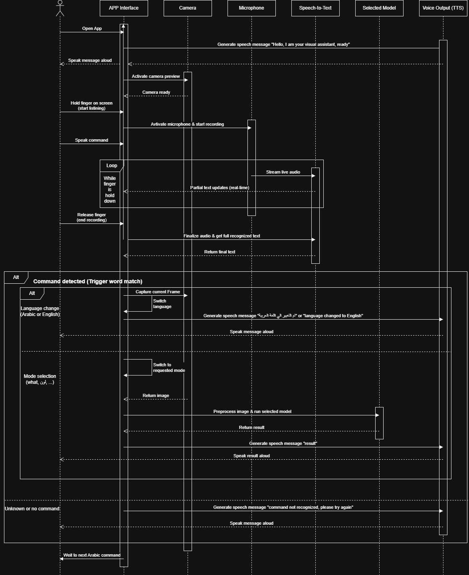

Data Flow Diagrams
Data Flow Diagrams (DFDs) show how data moves through the system, from input to processing to output, without worrying about the exact timing or sequence (that's what sequence diagrams do). We created Level 0 (the big-picture context diagram) and Level 1 (a more detailed breakdown) to understand and document how information flows in our offline mobile app for visually impaired users.
These diagrams are very useful because they give a clear, visual map of where data comes from, where it goes, how it's transformed, and what stores it.

DFD-level 0 (Context Diagram)
Shows the entire app as one big process, with external entities (like User and Camera) and the main data flows in and out. It answers "What goes in and out of the app?"
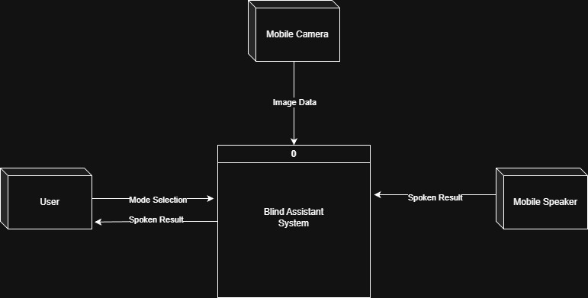
The context diagram presents the Blind Assistant System as a single high-level process. It shows the main interactions with the following external entities:
- Blind User: Provides mode selection and receives spoken results.
- Camera Device: Supplies image data to the system.
- Mobile Speaker: Outputs the audio result generated by the TTS service.

DFD-level 1
Zooms in to show the main sub-processes (e.g., Voice Input, AI Processing, etc.) and how data moves between them. "What are the major steps inside the app?"
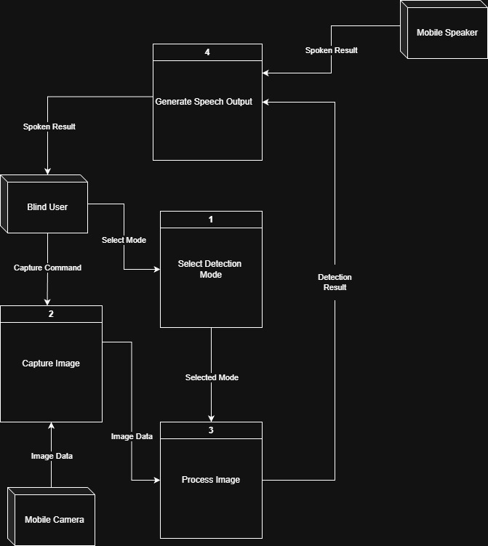
The Level 1 DFD decomposes the Blind Assistant System into four main processes with their data flows:
Process 1: Select Detection Mode – The user chooses the detection mode (Object Detection, Color Detection, or Text Recognition), which is then sent to Process Image.
Process 2: Capture Image – Receives the capture command, captures a photo, receives the image from the Mobile Camera, and sends it to Process Image.
Process 3: Process Image – Analyzes the image according to the selected mode and sends the result to Generate Speech Output.
Process 4: Generate Speech Output – Converts the detection result into spoken speech using the TTS service and sends the spoken result to the user via the Mobile Speaker.

State Diagram
State diagrams illustrate how the system (or its main entities) transitions between different conditions or modes in response to events, user actions, or internal logic. We included this diagram because our app has several complex states that need clear management to avoid errors, such as:
- The app being idle while waiting for user input (voice hold or button press)
- Switching between different detection modes (object, currency, color, text, face)
- Handling temporary states like "listening", "processing", "adding face", or "error"
- Managing language changes (Ar ↔ En) that affect both input (STT) and output (TTS)
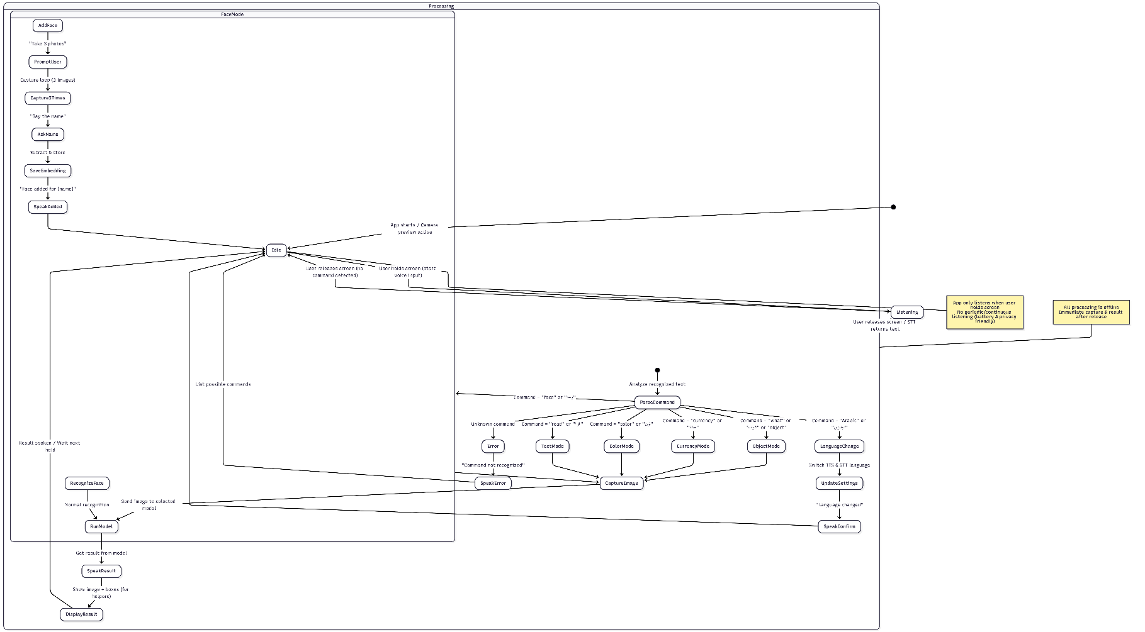
The diagram is very useful because it gives us a complete view of the app's behavior over time. It helps prevent bugs like getting stuck in one mode, failing to respond after an error, or not properly switching languages. It also makes it easier for the development team (especially the mobile team) to understand the lifecycle of the app and implement correct state transitions in code. Additionally, it clearly shows how the app is always ready for the next user action (hold to speak) and how it handles special cases (unknown commands, no detection, etc.). For the examiners, it demonstrates thoughtful design for a voice-first, accessible app.

Pseudocode
In this section, we provide pseudocode for the most complex and central part of the mobile app: the main processing loop that handles all models we did until Now (Object Detection, Color Detection, Text Extraction).
This pseudocode shows how the app core coordinates voice commands, image capture, model selection, processing, and voice feedback — all offline.

Object Detection
This pseudocode describes the core logic of the object detection module using the YOLOv11 model, including image preprocessing, model inference, non-maximum suppression (NMS), and generating spoken descriptions.
Algorithm ObjectDetectionFromImage(imageBytes)
Input: imageBytes (Uint8List) - The captured image in byte format
Output: Spoken description of detected objects
1. Decode imageBytes to originalImage using imgLib.decodeImage
2. If originalImage is null, speak "Failed to process image" and return
3. Preprocess the image:
- Compute scale = 640 / max(originalImage.height, originalImage.width)
- Resize originalImage to newWidth = originalImage.width * scale, newHeight = originalImage.height * scale
- Create letterboxImage (640x640) filled with gray color (114, 114, 114)
- Compute offsetX = (640 - newWidth) / 2, offsetY = (640 - newHeight) / 2
- Composite resized image into letterboxImage at (offsetX, offsetY)
4. Normalize letterboxImage to inputTensor (1 x 3 x 640 x 640) by dividing pixel values by 255.0
5. Run YOLO model inference:
- Create output tensor (1 x 84 x 8400)
- interpreter.run(inputTensor, output)

6. Extract detections from output:
- boxes = [], scores = [], classIds = []
- For i from 0 to 8399:
cx = output[0][0][i], cy = output[0][1][i], w = output[0][2][i], h = output[0][3][i]
classScores = output[0][4 to 83][i]
maxScore = max(classScores)
maxClassId = argmax(classScores)
if maxScore >= 0.25:
Add box [cx - w/2, cy - h/2, cx + w/2, cy + h/2] to boxes
Add maxScore to scores
Add maxClassId to classIds
7. If boxes is empty, speak "No objects detected" and return
8. Apply Non-Maximum Suppression (NMS):
- Sort indices by scores descending
- For each high-score index, suppress overlapping boxes with IOU > 0.45
9. Count objects per class from kept detections
10. Build speech text using buildArabicSpeech or buildEnglishSpeech based on language
11. Speak the result text
End Algorithm

Color Detection
This pseudocode describes the dominant color detection process using PaletteGenerator, including color mapping to Arabic names.
Algorithm DetectDominantColor(imageBytes)
Input: imageBytes (Uint8List)
Output: Spoken description of dominant color
1. Decode imageBytes to image using imgLib.decodeImage
2. If image is null, speak "Failed to process image" and return
3. Generate palette using PaletteGenerator.fromImageProvider with maximumColorCount = 10
4. Get dominantColor = paletteGenerator.dominantColor.color
5. If dominantColor is null, speak "No dominant color detected" and return
6. Extract RGB = (dominantColor.red, dominantColor.green, dominantColor.blue)
7. Define colorMap as dictionary of RGB tuples to Arabic color names (e.g., (255, 0, 0) -> "أحمر")
8. Find closest color:
- minDistance = infinity
- closestName = "لون غير معروف"
- For each rgb, name in colorMap:
distance = sqrt( (r - rgb.r)^2 + (g - rgb.g)^2 + (b - rgb.b)^2 )
if distance < minDistance:
minDistance = distance
closestName = name
9. Speak "اللون الرئيسي في الصورة هو [closestName]"
End Algorithm

Text Detection
This pseudocode describes the text extraction process using Google ML Kit Text Recognition, including sorting blocks and lines.
Algorithm ExtractTextFromImage(imagePath)
Input: imagePath (string)
Output: Spoken text extracted from the image
1. Create InputImage from imagePath using InputImage.fromFilePath
2. Process image with TextRecognizer to get recognizedText
3. If recognizedText.blocks is empty, speak "No text detected in the image" and return
4. Sort blocks by boundingBox.top (from top to bottom)
5. For each sorted block:
- Sort lines in block by boundingBox.top
- For each sorted line:
- lineText = line.text.trim()
- Replace multiple spaces with single space
- If lineText not empty, add to lines list
- Add empty line as separator between blocks
6. fullText = join lines with '\n' and trim
7. If fullText is empty, speak "Detected text but not readable" and return
8. Speak "النص المكتشف في الصورة:\n\n[fullText]"
End Algorithm

Entity Relationship Diagram (ERD)
Even though our app is fully offline and doesn't use a traditional heavy database server, we still need a small local storage mechanism on the phone to save persistent data. The only thing that needs to be saved across app sessions is the face recognition data (user-added faces with their names and embeddings). Everything else (like current detection results, settings like language) is either in-memory or saved in simple shared preferences/files. So, the ERD is very simple and focused only on the face recognition part.
The ERD helps us clearly define what data we need to store, how entities are related, and what attributes each one has. It's useful for planning the local database (SQLite on Android) so we don't miss anything (like saving multiple photos per person) and to avoid errors later when coding the face module. It also shows the examiner that we thought about data structure, even in an offline app. Since the app is small, we kept the ERD minimal — only what's really needed.
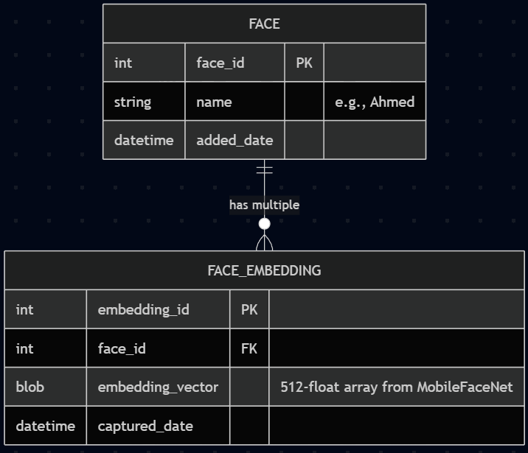
What the diagram shows
Entities (tables): User (for settings if we expand later), Face (each person added), and FaceEmbedding (the actual vector data from MobileFaceNet).
Relationships: One user can have many faces (1:N), and one face can have multiple embeddings (1:N) for better accuracy (e.g., 3 photos of the same person).
Attributes: Primary keys, foreign keys, and main fields.
Cardinality: 1 to N (crow's foot notation) to show how many.

UML Class Diagrams
UML Class Diagrams show the main classes (objects) in the system, their attributes, methods, and relationships. Since our app is offline and mobile, we designed it with a clean, modular structure. The diagram focuses on the core classes that handle the app logic, models, and voice.
It helps us see the structure of the code before writing it. It shows how classes connect (inheritance, composition), what data each class holds, and what functions they perform. This prevents messy code later and makes it easy to explain the design to the doctor. We kept it high-level — not every tiny method, just the important ones.
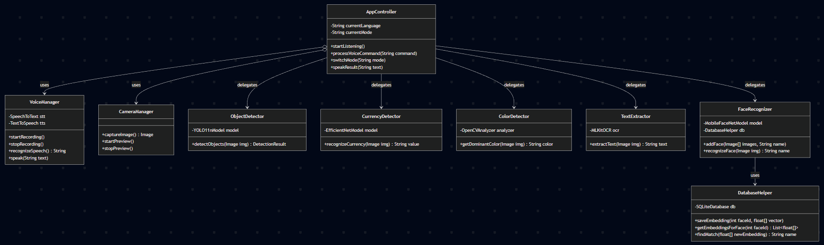
What the diagram shows
Main classes: AppController (the heart), VoiceManager, CameraManager, each AI module (e.g., ObjectDetector), and DatabaseHelper.
Attributes: Important variables like currentMode, language.
Methods: Key functions like processCommand(), captureImage(), speakResult().
Relationships: Composition (AppController has VoiceManager), dependency (modules use CameraManager), etc.

Chapter 4: Implementation Aspects
This section presents the practical implementation details of the proposed offline assistive mobile application. It focuses on the system architecture, the technologies and tools used, and the current functional prototype. The purpose of this section is to demonstrate how the theoretical design decisions described in previous chapters are translated into a real, working system.
Since the project is in two terms, the first for documentation and planning, the second for coding and testing, we're still in the early stages, but we've started some basic implementation like training some models and sketching the app.

Architecture Overview
The proposed system follows a modular, layered, and offline-first architecture, designed specifically for mobile devices. All core functionalities are executed locally on the user’s device without relying on external servers or cloud services. This architectural choice ensures low latency, user privacy, and reliability in environments with limited or no internet connectivity.
Block Diagram Description:
The system architecture is a high-level block diagram that shows how all the parts of the app connect and work together. The diagram has blocks for each component, connected by arrows to show data flow.
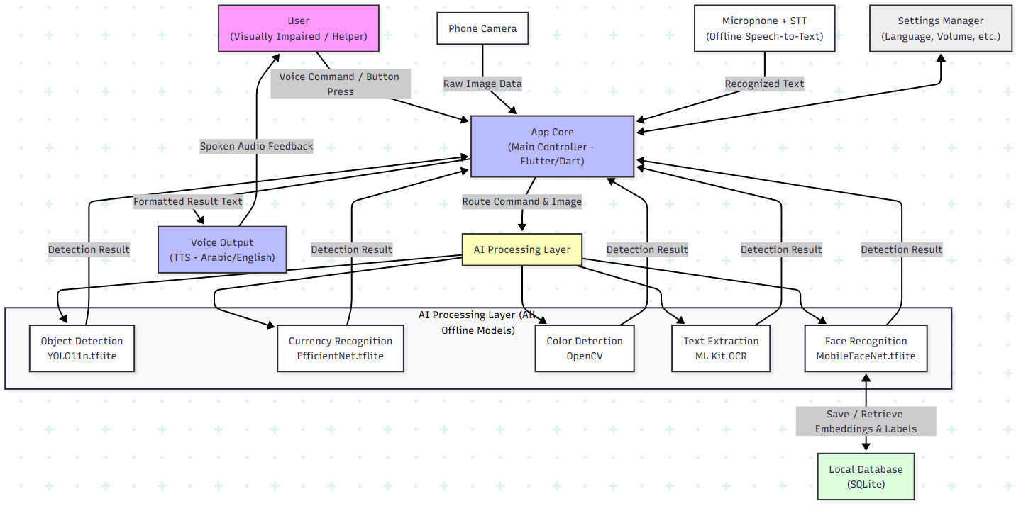
At a high level, the system consists of five main layers:
- User Interaction Layer
- Mobile Application Core Layer
- AI Inference Layer
- Local Data Storage Layer
- Hardware Interface Layer
Component Interaction Explanation:
- The User Interaction Layer allows visually impaired users to control the application using voice commands or simple gestures.

- The Mobile Application Controller manages feature selection, system states, and navigation.

- The Camera Manager captures real-time images and video frames.

- The Image Preprocessing Module prepares images for model inference (resizing, normalization).

- The AI Inference Engine loads and runs multiple TensorFlow Lite models locally.

- The Text-to-Speech Engine converts prediction results into spoken feedback.

- All models and user data are stored and accessed through local storage.
This architecture enables independent operation of each feature while maintaining a unified and scalable system.

Datasets
Datasets play a critical role in the development, training, and evaluation of the machine learning models used in this project. Since the proposed system relies on multiple computer vision tasks, different datasets were selected or created to support each functionality while ensuring compatibility with offline mobile deployment.

Object Detection Dataset
The object detection module is based on a YOLO architecture trained using the MS COCO (Common Objects in Context) 2017 dataset.
Dataset Description:
- The MS COCO dataset is a large-scale dataset designed for object detection, segmentation, and recognition tasks.
- It contains images of real-world scenes with multiple objects appearing in complex backgrounds.
Key Characteristics:
- Number of classes: 80 common object categories
- Annotations: Bounding boxes and class labels
- Dataset splits used:
  - Training set (COCO 2017 Train)
  - Validation set (COCO 2017 Val)
Justification:
- Provides a strong baseline for recognizing common objects encountered in daily life.
- Widely used and well-documented, enabling reliable benchmarking.
- Suitable for transfer learning and fine-tuning.

Limitations and Future Extension:
- The dataset does not include certain objects that are highly relevant to visually impaired users (e.g., stairs, curbs, traffic signals).
- Additional custom data will be collected and added in Senior Project 2 to Fine Tuning YOLO model and extend the class set.

Currency Recognition Dataset
For the currency recognition module, a custom-built dataset was created by the project team.
Dataset Description:
- Images of Egyptian currency notes captured under varying lighting conditions, orientations, and backgrounds.
- Includes different denominations relevant to local use.
Key Characteristics:
- Image-based classification dataset
- Labeled by denomination value
- Captured using smartphone cameras to match real usage scenarios
Justification:
- Public datasets for local currency are limited or unavailable.
- Custom data ensures better domain relevance and higher practical accuracy.

Face Recognition Dataset
The face recognition module does not rely on a traditional static dataset.
Approach:
- Uses a user-generated dataset collected during application usage.
- Each user registers familiar individuals by capturing multiple facial images.
Key Characteristics:
- Dynamic, personalized dataset
- Stored locally on the device
- Used to generate facial embeddings rather than class labels
Justification:
- Improves privacy by avoiding cloud storage.
- Allows customization based on the user’s social environment.

Text Recognition Dataset
Text recognition is handled using offline OCR tools integrated within the mobile application.
Dataset Handling:
- No explicit training dataset is used by the project team.
- OCR models rely on pre-trained text recognition systems embedded in the mobile framework.
Current Support:
- English text recognition is supported.
- Arabic text recognition is planned for future enhancement.
Justification:
- Ensures efficient and reliable text extraction on mobile devices

Color Identification Dataset
Color identification is implemented using image processing techniques rather than a trained machine learning model.
Data Source:
- Pixel color values extracted directly from camera frames.
Approach:
- Dominant color extraction using clustering and color space transformations.
- No labeled dataset is required.
Justification:
- Lightweight and efficient for mobile devices.
- Eliminates the need for large datasets or model training.

Dataset Management and Preparation
All datasets used in this project were:
- Preprocessed to match model input requirements.
- Normalized and resized to ensure consistency.
- Evaluated for suitability in offline inference scenarios.
Where applicable, datasets were split into training and validation sets to prevent overfitting and ensure generalization.

Tools, Technologies, and Programming Languages
Overview
The proposed system is built using a set of modern machine learning, deep learning, and mobile development tools selected based on performance, efficiency, and suitability for offline deployment, focusing on lightweight models for phones.

Programming Languages
Python: Model training, evaluation, and conversion
Dart: Flutter mobile application development

Frameworks, Libraries and Models
- Flutter: Cross-platform mobile UI development

- Ultralytics YOLO (For Object Detection):
YOLO "You Only Live Once" is a popular model for real-time object detection from Ultralytics. We use the nano version 11 (YOLO11n.tflite) because it's small and optimized for real-time inference on mobile devices. It detects 80 common classes like "person" or "bus" from COCO dataset. We converted it to TFLite for offline use, so it runs locally without internet. We intend to improve it and add new labels and categories that visually impaired people may need in their daily lives.

- EfficientNet (Currency Recognition):
EfficientNet -based classifier from Google is a CNN model known for accuracy with low resource use. We fine-tuned it on our custom Egyptian “local” currency dataset (photos of EGP notes in different conditions). It's efficient for phones and predicts currency values like "50 EGP" if it sees a note in the image. After tuning this model, We converted it to TFLite for offline use.
- Color Identification:
This is a simple algorithm (not a full model) using a lightweight color classification from OpenCV to find the dominant color in an image or region and describe colors like "red shirt" via voice. It's lightweight and works offline.

- ML Kit (Text Extraction):
Google's ML Kit is a mobile SDK for on-device AI. We use its offline OCR (Optical Character Recognition) to extract and read text from images without internet access. It supports English and Arabic, making it perfect for our app.

- MobileFaceNet (Face Recognition):
MobileFaceNet is a lightweight face model for mobiles, based on FaceNet. It operates in two stages: first, creates facial embeddings (unique codes) from registered user images, so Users add photos of people (e.g., family), and second: comparing new faces against stored embeddings by cosine similarity to match faces and identify known individuals or report unknown persons. We use TFLite version for offline work.

These tools are chosen because they're free, open-source, and run on Android/iOS without cloud. All models are converted to TensorFlow Lite (TFLite) format to ensure compatibility with Android and Flutter-based mobile applications and low battery use. Audio feedback is provided through text-to-speech (TTS) systems integrated directly into the mobile platform.
The combination of these tools allows the system to deliver accurate, fast, and privacy-preserving assistance to visually impaired users in a fully offline environment. This keeps the app simple and accessible.

Prototype Implementation (Screens)
A functional prototype of the application has been implemented to validate the feasibility of the proposed system and to demonstrate the core functionalities. The prototype focuses on usability, accessibility, and correct model integration rather than final UI aesthetics.

Object Detection
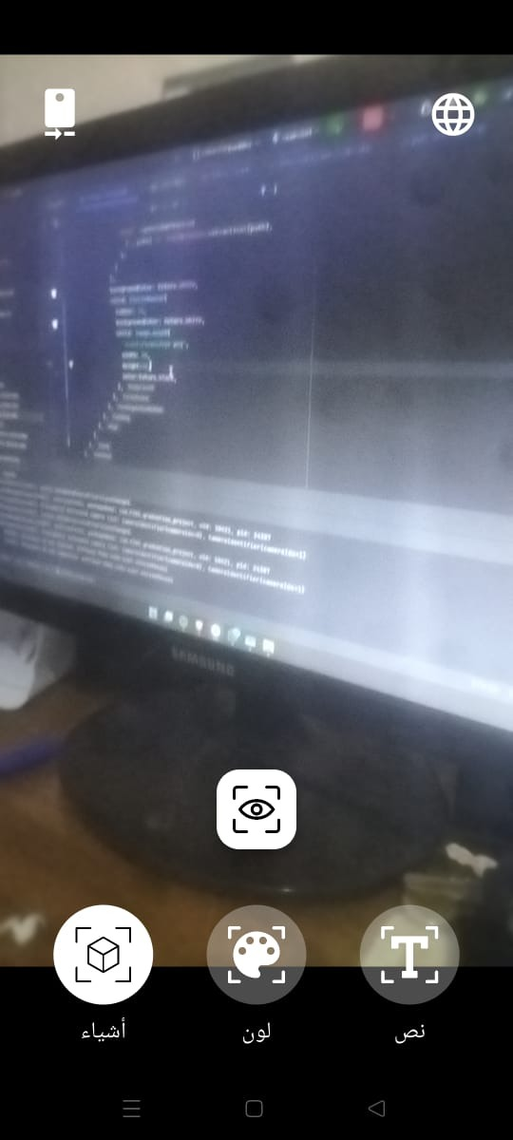
After Click at “أشياء” or saying “What” or “شئ” the app will capture instance image and send it to object detection model ‘Yolo11n’ and extract object inside this image and say result “There is a screen” or “هناك شاشة”, language change if we click on language button ‘upper right’ to change from English to Arabic or reverse.

Color Detection
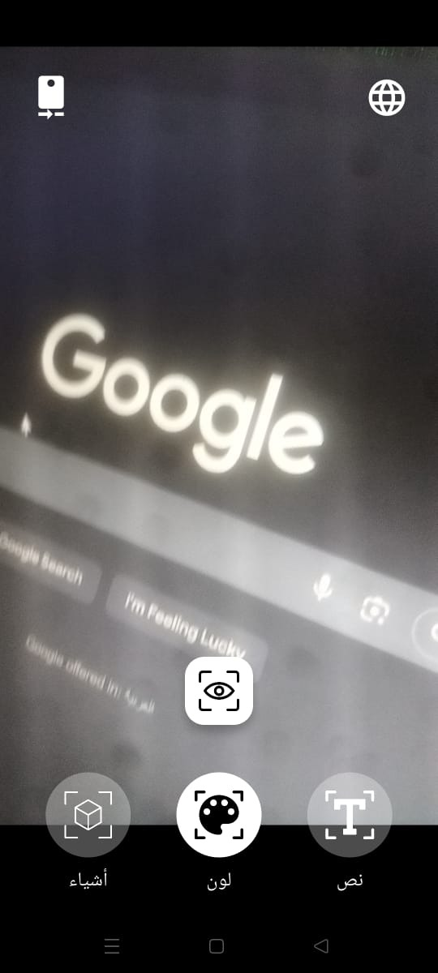
After Click at “لون” or saying “color” or “لون” the app will capture instance image and send it to color detection model ‘OpenCV and extract dominant color inside this image and say result “Grey” or “رمادي”, language change if we click on language button ‘upper right’ to change from English to Arabic or reverse.

Text Extraction

After Click at “نص” or saying “text” or “نص” the app will capture instance image and send it to Text Extraction model ‘ML kit’ and extract text inside this image and say result “Google”, language change if we click on language button ‘upper right’ to change from English to Arabic or reverse.

Chapter 5: Future Work Plan
This chapter presents the planned activities for Senior Project 2, building upon the outcomes achieved in Senior Project 1. While the first phase focused on system analysis, design, and partial implementation, the second phase will emphasize completion, enhancement, optimization, and full integration of all system components to deliver a robust, reliable, and deployable offline assistive mobile application for visually impaired users.

Remaining Tasks
Based on the current project status, several key technical and functional tasks remain to be completed in Senior Project 2. These tasks are categorized according to system components.

Object Detection Model Enhancement
- Extend the existing YOLO-based object detection model beyond the 80 COCO classes.
- Identify and prioritize additional object classes that are highly relevant to visually impaired users (e.g., doors, stairs, traffic lights, crosswalks, obstacles).
- Collect or curate additional datasets for the newly required classes.
- Retrain and fine-tune the object detection model.
- Convert the improved model to TensorFlow Lite with optimized precision.
- Reintegrate the updated model into the mobile application.

Currency Recognition Model Completion
- Redesign and retrain the currency recognition model to improve classification accuracy.
- Investigate and resolve issues related to TensorFlow Lite conversion.
- Apply model optimization techniques to ensure compatibility with mobile devices.
- Validate the model performance under different lighting conditions and backgrounds.
- Successfully integrate the currency recognition model into the offline mobile application.

Text Extraction Enhancement (OCR)
- Extend the current text extraction functionality beyond English.
- Evaluate alternative offline OCR solutions capable of supporting Arabic text.
- Integrate multilingual text recognition into the application.
- Ensure correct pronunciation and language handling in the text-to-speech output.

Face Recognition System Stabilization
- Resolve issues related to saving and managing face embeddings in local storage.
- Improve face enrollment and recognition reliability.
- Implement better handling of unknown or unregistered faces.
- Optimize performance to ensure real-time inference on mobile devices.
- Enhance security and privacy for stored facial data.

Color Detection Feature Enhancement
- The current OpenCV code detects dominant colors, but it's basic and doesn't handle multiple colors well.
- improve the code to describe more details

Voice Command System Improvement
- Expand the voice command vocabulary for more flexible interaction.
- Improve command recognition accuracy, especially in Arabic.
- Implement better command parsing and error handling.
- Allow users to customize voice commands based on personal preference.

Mobile Application Refinement
- Improve user interface accessibility and usability.
- Enhance audio feedback clarity and timing.
- Optimize performance and memory usage.
- Conduct extensive testing on different devices.
- Fix bugs and stabilize all integrated features.

System Evaluation and Testing and Conduct Surveys
- Conduct controlled usability testing with visually impaired users if possible.
- Evaluate system accuracy, response time, and reliability.
- Collect feedback and refine system behavior accordingly.
- Prepare final evaluation metrics and documentation.
We couldn't do surveys yet because of exams and no prototype, but now with the app ready, we'll go to Taha Hussein Center in late January (as they said), show the prototype to blind students, do interviews/surveys (10-20 people), and use the feedback to fix bugs or add features.

Documentation and Final Report:
Update the report with results from final testing, add full code explanations, and prepare for final presentation with final version of our app.

Proposed Timeline
The following timeline outlines the estimated duration for completing the remaining tasks during Senior Project 2. The timeline assumes a typical academic semester duration.
Phase | Task | Estimated Duration
1 | Object detection model enhancement | 2 weeks
2 | Currency model retraining & TFLite conversion | 2 weeks
3 | Arabic OCR integration | 1 weeks
4 | Face recognition stabilization | 1 weeks
5 | Voice command enhancement | 1 weeks
6 | Mobile app optimization & integration | 3 weeks
7 | Testing, evaluation, and refinement | 1 weeks
8 | Final documentation & presentation | 1 week
Total Estimated Duration: Approximately 12 weeks

Anticipated Risks and Challenges
Despite careful planning, several risks and challenges may arise during Senior Project 2. These risks have been identified along with proposed mitigation strategies.

Model Performance Limitations
Risk:
Models may not achieve the desired accuracy or real-time performance on mobile devices.
Solutions:
- Apply model pruning and quantization techniques.
- Test multiple lightweight architectures.
- Optimize input resolution and inference frequency.

TensorFlow Lite Conversion Issues
Risk:
Certain models may fail to convert correctly to TensorFlow Lite.
Solutions:
- Redesign model architectures for mobile compatibility.
- Avoid unsupported operations.
- Use post-training quantization instead of full quantization when necessary.

Arabic OCR Accuracy
Risk:
Offline Arabic OCR may produce inaccurate or incomplete text extraction.
Solutions:
- Evaluate multiple OCR engines.
- Apply preprocessing techniques to improve image quality.
- Limit OCR scope to commonly used text formats initially.

Face Recognition Storage and Privacy
Risk:
Storing face embeddings locally may lead to data corruption or privacy concerns.
Solutions:
- Use secure local storage mechanisms.
- Encrypt sensitive data.
- Implement clear user consent and deletion options.

Voice Command Recognition Errors
Risk:
Voice commands may be misinterpreted due to accents, noise, or speech variations.
Solutions:
- Implement confirmation prompts.
- Allow command repetition.
- Use keyword-based activation instead of continuous listening.

Limited Access to Target Users for Surveys and Evaluation
Risk:
One of the main challenges faced during Senior Project 1 was the limited access to visually impaired users for conducting surveys, interviews, and usability evaluations. Direct feedback from the target users is essential for validating system requirements, assessing usability, and refining system functionalities.
Despite efforts to reach visually impaired individuals, practical constraints limited the ability to conduct formal surveys during the current project phase. The project team contacted the Taha Hussein Center for Blind Students at Alexandria University, which serves a large number of visually impaired students. The center expressed interest in collaborating and recommended conducting in-person interviews after presenting a functional prototype to ensure meaningful feedback.

However, due to the early development stage of the project, mid-term academic examinations, and later final examinations, it was not possible to prepare a sufficiently complete prototype within the proposed timeframe. Additionally, the center’s director advised scheduling the visit at the end of January, which occurs after the Senior Project 1 discussion period.
Impact:
The inability to conduct surveys and interviews during Senior Project 1 limits the availability of direct user feedback in the current phase. This may affect the validation of certain user requirements and usability assumptions. Difficulty in conducting real-world testing and Getting User Feedback with visually impaired users.
Mitigation:
- Conduct comprehensive surveys, interviews, and usability testing during Senior Project 2 after completing a stable functional prototype.
- Visit the Taha Hussein Center for Blind Students as scheduled at the end of January to collect real-world feedback from visually impaired users.
- Use the collected feedback to refine system features, improve usability, and validate design decisions.
- Document survey results and user feedback as part of the Senior Project 2 evaluation and final report.
In the worst-case scenario, if we are unable to conduct the survey:
- Use expert reviews and simulated testing scenarios.
- Collaborate with accessibility organizations if possible.
- Gradually refine the system based on indirect feedback.

References
- World Health Organization. (2025). "Blindness and vision impairment".
Link

- G. Giraud et al., “A Survey on the Needs of Visually Impaired Users and Requirements for a Virtual Assistant in Ambient Assisted Living,” IEEE Access, 2019.
Link

- M. A. Hersh, “Mobile Applications for Visually Impaired Users: A User Survey,” International Journal of Educational Technology, ERIC, 2017.
Link

- M. R. Luo et al., “Assistive Vision Technologies for People with Visual Impairment,” Annual Review of Vision Science, vol. 9, 2023.
Link

- A. K. Sharma et al., “Intelligent Sensing Systems for Visually Impaired Assistance,” Sensors (MDPI), vol. 24, no. 7, 2024.
Link

- S. R. Tapu et al., “Computer Vision–Based Assistive Systems for the Visually Impaired: A Review,” PMC, 2024.
Link

- A. Al-Jumaily et al., “AI-Based Mobile Assistance for Blind and Visually Impaired Users,” arXiv preprint arXiv:2505.19325, 2025.
Link

- J. M. Loomis et al., “Assistive Technology and Independence for People with Visual Impairment,” PMC, 2025.
Link

- Mekonnen, F. Y., et al. (2025). "Development of a Fully Autonomous Offline Assistive System for Visually Impaired Individuals: A Privacy-First Approach." MDPI Sensors.
Link

- Raskar, A., et al. (2025). "Visual Recognition Based Mobile Application for Visually Impaired People." International Research Journal on Advanced Engineering Hub.
Link

- Kamran, M. A., et al. (2025). "Visually: Assisting the Visually Impaired People Through AI-Assisted Mobility." ResearchGate.
Link

- Ghanem, A. M., et al. (2025). "Recognizing Egyptian Currency for People with Visual Impairment Using Deep Learning Models." Scientific Reports.
Link

- Bandara, A. (2025). "Money Recognition for the Visually Impaired: A Case Study on Sri Lankan Banknotes Using Fine-Tuned CNN." arXiv.
Link

- Authors from IOPScience. (2025). "Real-time Object Detection and Face Recognition System to Assist the Visually Impaired." IOPScience.
Link

- Shivakumar, N., et al. (2025). "Colored Object Detection for Blind People Using CNN." ResearchGate.
Link

- Authors from IJARCCE. (2025). "VISIONSPEAK: OBJECT DETECTION AND VOICE ASSISTANCE FOR VISUALLY IMPAIRED PEOPLE." IJARCCE.
Link

- Authors from ResearchGate. (2025). "A Visually Impaired Mobile Application for Currency Recognition using MobileNetV2 CNN Architecture." ResearchGate.
Link

- Authors from ACM. (2025). "Image Recognition Tools for Blind and Visually Impaired Users: An Emphasis on the Design Considerations." ACM Transactions on Accessible Computing.
Link

- Authors from IJRASET. (2025). "AI-Driven Vision Assistance for Visually Impaired." IJRASET.
Link

- Authors from ScienceOpen. (2025). "Smart Assistive Navigation System for Visually Impaired People." ScienceOpen.
Link
- Authors from ResearchGate. (2025). "AI-Powered Accessibility in Mobile Applications: Advancing Inclusive Design through Machine Learning Innovations." ResearchGate.
Link

- Authors from IJSREM. (2025). "Assistive Object Recognition and Tracking System for the Visually Impaired Using CNN." IJSREM.
Link

- Authors from International Journal of Computer Applications. (2025). "An Assistive Reading System for Visually Impaired using OCR and TTS." International Journal of Computer Applications.
Link

- Authors from MDPI. (2025). "Computer Vision-Based Obstacle Detection Mobile System for Visually Impaired Individuals." MDPI.
Link

- Pratap, A., et al. (2025). "Adaptive Object Detection for Indoor Navigation Assistance: A Performance Evaluation of Real-Time Algorithms." arXiv.
Link

